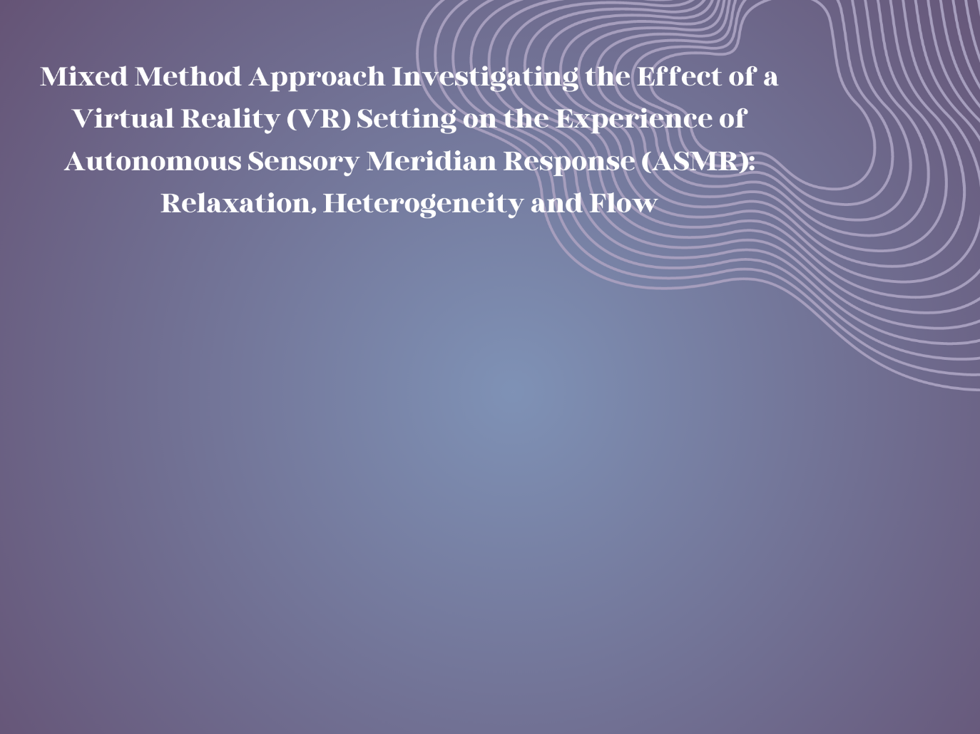

**Autonomous Sensory Meridian Response (ASMR)** is a sensory phenomenon characterised as a heightened response to audio-visual stimuli (Barratt & Davis, 2015). It is accompanied by deep feelings of relaxation, positive affect and often tingles (Poerio et al., 2018). No study to date has looked at the influence of immersion on the experience of ASMR, despite users describing the experience as arising from ‘losing’ themselves in the content.

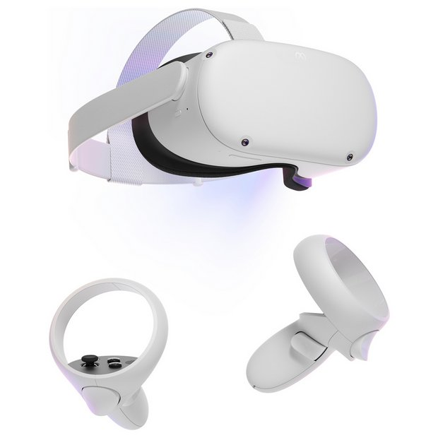**The current study’s aim** was to investigate the effect of a virtual reality setting on the experience of ASMR. It was hypothesised that watching an ASMR video in VR would be more relaxing (lower heart rate), heighten ASMR (greater *ASMR-15* score) and heighten flow (greater *Flow State Scale* score), than in the remaining conditions. The other conditions being watching an ASMR video on a laptop and watching a non-ASMR video on a laptop and in VR. Participants (n = 10) were invited to a lab and while watching the video their heart rate was measured (as an objective measure of relaxation). Afterwards they completed two questionnaires measuring their experience of flow (colloquially known as ‘being in the zone’) and overall ASMR-iness. Subsequently they engaged in a short semi-structured interview where insight into their subjective experience could be gathered. To manipulate the level of immersion the Meta Quest 2 headset was used.

**Findings included** significant differences in the ASMR-iness between watching an ASMR video on a laptop versus watching a non-ASMR video on a laptop. While non-significant, ASMR was greater when watching an ASMR video in VR compared to the non-ASMR conditions. Analysis of the interview data revealed that participants found that the ASMR VR condition just as relaxing and pleasant as watching ASMR on a laptop. Particularly as VR made the experience more realistic and brought rise to altered states of consciousness like warped perception of the passing of time. While 70% of participants speculated that had they watched the ‘perfect’ video in VR their experience would have been greater than watching the same ASMR video on a laptop.

**What does this mean?**

Findings align with previous research finding that it is possible to evoke ASMR in a controlled setting and in the presence of another individual, namely in a lab with a researcher (Poerio et al., 2018). It also dispels existing myths that stigmatise ASMR by considering it to be a pseudo-phenomenon. Moreover, this study poses well as pilot since it can be inferred that due to the benefits of immersive technology, such as heightened escapism or realism, the experience of ASMR can be heightened. Due to the study being underpowered and faced by resource limitations, future research making use of more participants and ASMR VR content better suited to participants’ preferences is advised. Overall, it can be inferred that by focusing all attention onto the ASMR-triggering content individuals derive similar benefits as when they engage in meditation. Therefore, by heightening the experience of the source of sensory information this in turn reduces external distractors, perhaps enhancing the experience of ASMR.

**References**

Barratt EL, Davis NJ. 2015. Autonomous Sensory Meridian Response (ASMR): a flow-like mental state. PeerJ 3:e851 <https://doi.org/10.7717/peerj.851>

Poerio, G. L., Blakey, E., Hostler, T. J., & Veltri, T. (2018). More than a feeling: Autonomous sensory meridian response (ASMR) is characterized by reliable changes in affect and physiology. PloS one, 13(6), e0196645. <https://doi.org/10.1371/journal.pone.0196645>